🚀 Capstone Project: Modern Data Engineering & AI-Powered Analytics on Databricks
Submitted by: Nithin Sai Palreddy
Github URL : https://github.com/nithinsai7/databricks_phase2_assessment_nithin.git
Catalog and Schema building:
Create 2 catalog’s each for one environment, dev and PROD and each catalog should contain 3 schemas namely bronze, silver and gold
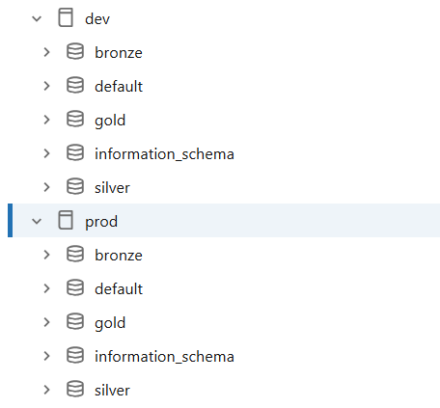
Datasets Uploading:
Create a volume in bronze schema of both catalogs.
Upload the required datasets into volumes in bronze schema of all 2 catalogs, which will be helpful while pushing the codes to production.
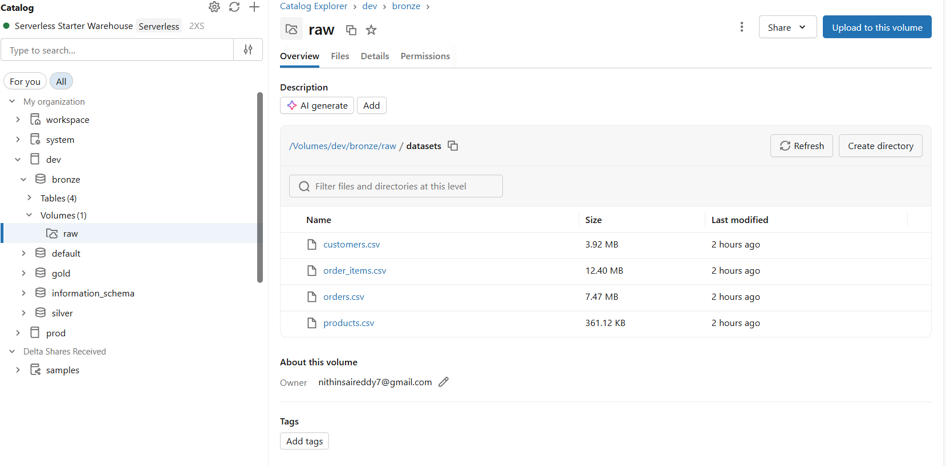
Above is the image of files uploaded into volume
Task 1 : Bronze Layer Tables
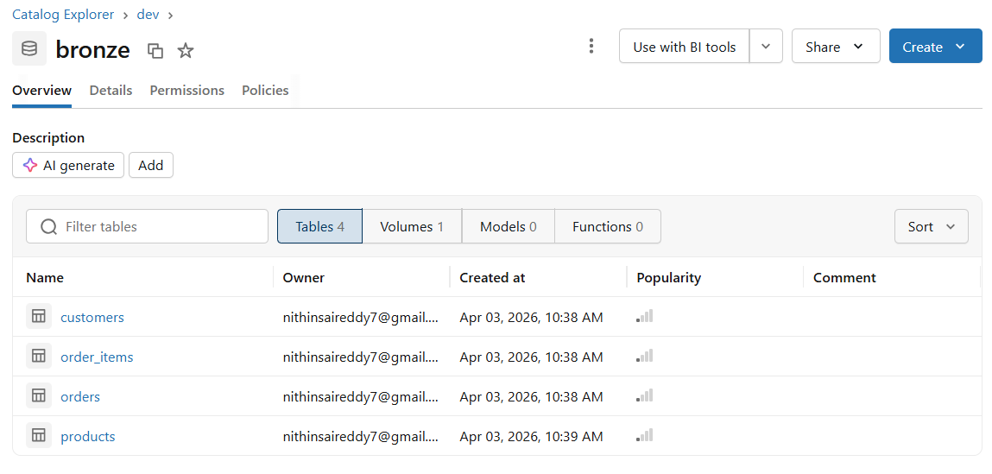
Above image shows the bronze tables that are created using above csv files.
Task 2 : Silver Layer
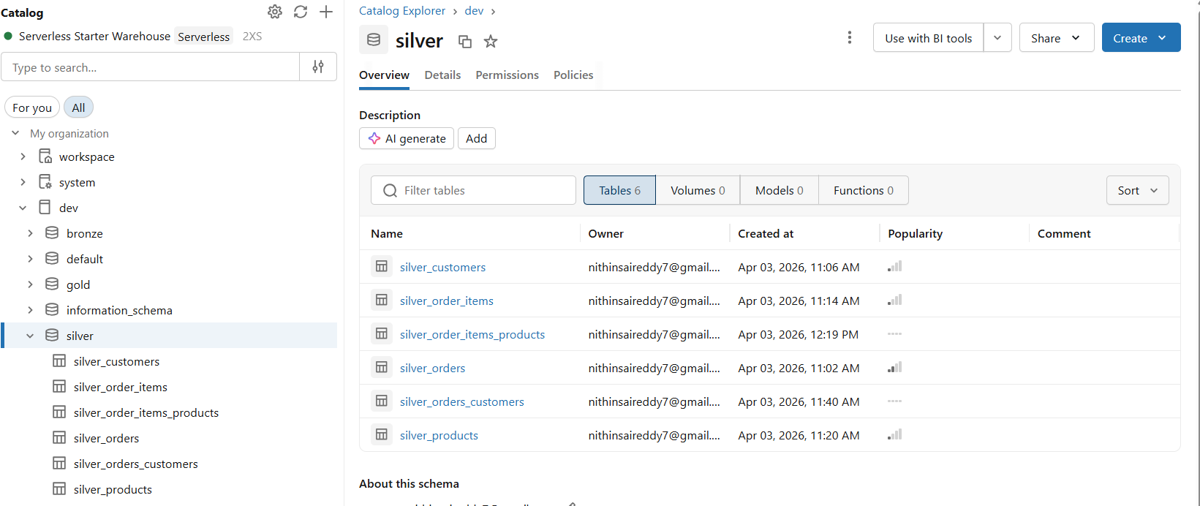
Above images shows the clean tables that are created in silver layer. Please check the github repo link for notebooks code.
Task 3 : Gold Layer
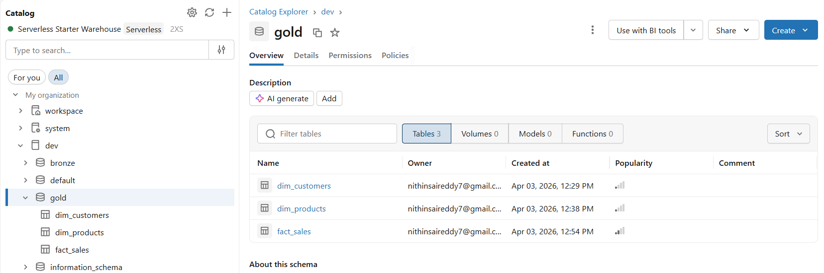

Task 4 : Spark Advanced Optimization
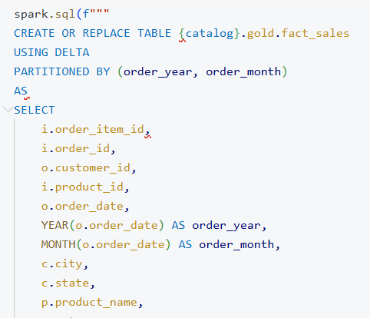
Partitoning by order year and order month

Task 5 : Delta Lake Optimization
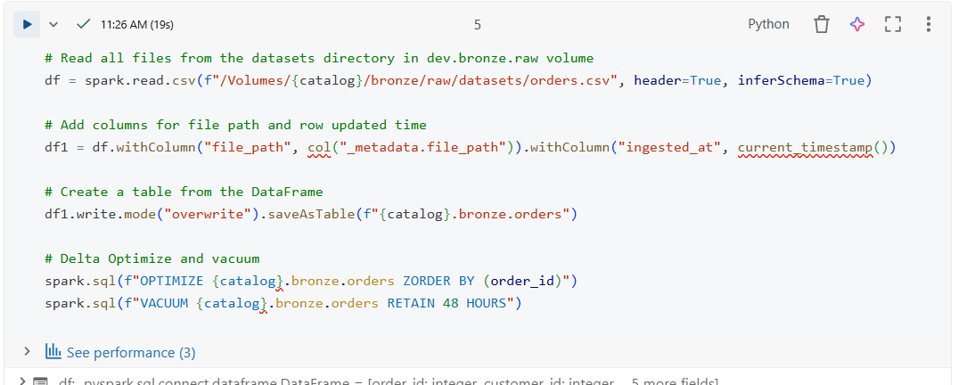
Optimization and Vacuum
Task 6 : CICD with Databricks
Github URL : https://github.com/nithinsai7/databricks_phase2_assessment_nithin.git

Task 7 : AI + BI (Genie / Dashboard)
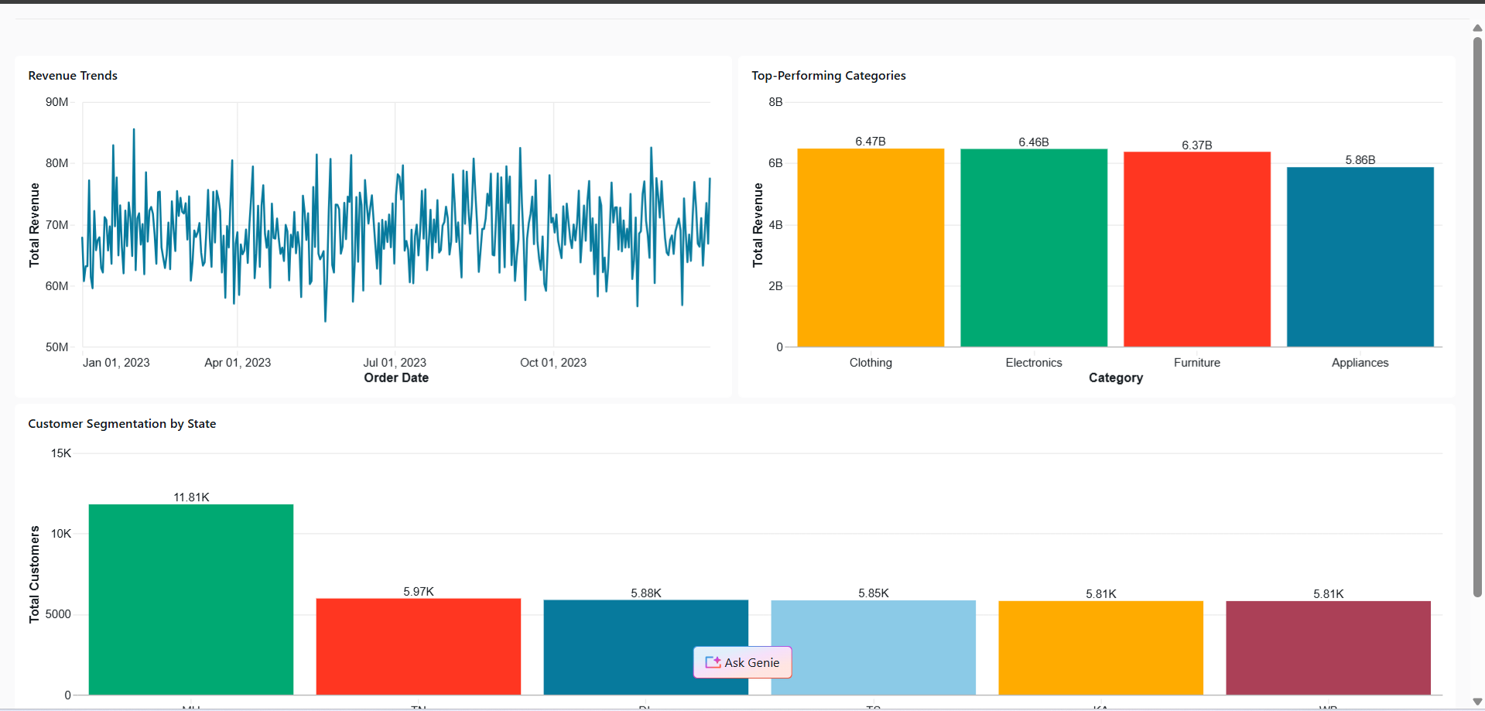

Genie
